**E-Commerce Platform for Local Craftsmen: Vikreta**

**An Engineering Project in Community Service**

**Phase – II Report**

***Submitted by***

|  |  |  |
| --- | --- | --- |
| **Sl. No.** | **Register Number** | **Name** |
| 1. | 21MEI10060 | Kuldeep Kumar Jha |
| 2. | 21MEI10022 | Yashwardhan Rastogi |
| 3. | 21MEI10012 | Sanskar Singh Chandel |
| 4. | 21MEI10050 | Manjari Sharma |
| 5. | 21MEI10021 | Pankaj Kumar |
| 6. | 21MEI10056 | Jatin Aggrawal |
| 7. | 21MIM10002 | Rahul Nihalani |
| 8. | 21MIM10003 | Shwetank Thakur |
| 9. | 21BCE11284 | Amar Rathour |
| 10. | 21BCY10106 | Aryan Thapa |

***in partial fulfillment of the requirements for the degree of***

***Bachelor of Engineering and Technology***



**VIT Bhopal University**

**Bhopal, Madhya Pradesh**

**December,2023**



**Bonafide Certificate**

Certified that this project report titled **“ E-Commerce Platform for Local Craftsmen: Vikreta ”** is the bonafide work of “ 21MEI10060 Kuldeep Kumar Jha, 21MEI10022 Yashwardhan Rastogi, 21MEI10012 Sanskar Singh Chandel, 21MEI10050 Manjari Sharma, 21MEI10021 Pankaj Kumar, 21MEI10056 Jatin Aggrawal, 21MIM10002 Rahul Nihalani, 21MIM10003 Shwetank Thakur, 21BCE11284 Amar Rathour, 21BCY10106 Aryan Thapa **”** who carried out the project work under my supervision.

This project report (Phase I) is submitted for the Project Viva-Voce examination held on 14th Dec 2023.



**Dr. Vijay Kumar Patidar**

**Supervisor**

1. **INTRODUCTION**An innovative online marketplace designed to empower local craftsmen by expanding their reach and showcasing their distinctive, handmade creations to a broader audience. More than just a conventional marketplace, our platform integrates cutting-edge technologies to elevate user experiences and optimize operational efficiency. Through innovative features such as an Automated Filtration and Recommendation mechanism, users can effortlessly discover products tailored to their preferences, enhancing the overall shopping experience.

Our commitment to quality extends to secure data storage, ensuring the protection of sensitive information. This advanced technological integration not only sets us apart but also underscores our dedication to fostering a seamless and secure environment for both craftsmen and consumers. By leveraging these state-of-the-art tools, we aim to revolutionize the online marketplace landscape, providing a dynamic platform that champions local craftsmanship while meeting the evolving expectations of a diverse and discerning audience. Join us on this transformative journey as we connect talented craftsmen with a global clientele, opening up new possibilities and opportunities in the digital marketplace.

**1.1 Motivation**

The inception of the "Indian Crafts and Artifacts" initiative, known as "Vikreta: E-commerce Platform for Local Craftsmen," stems from a passionate commitment to spotlight and archive the expansive spectrum of crafts and creations crafted by Indian artisans. Motivated by the cultural richness inherent in these artistic endeavors, which traverse both traditional and contemporary expressions, Vikreta emerges as a manifestation of this profound motivation. The primary objective of the platform is to establish a digital marketplace exclusively dedicated to these skilled craftsmen, providing a gateway for a global audience to explore and acquire authentic and one-of-a-kind Indian craftsmanship. Vikreta aspires to be a conduit that not only connects craftsmen with a broader market but also preserves and celebrates the cultural heritage encapsulated in every meticulously crafted piece.

**1.2 Objective**

Vikreta's key objectives center on developing a user-friendly interface to elevate the overall shopping experience. Our focus includes implementing automated systems for personalized product recommendations, prioritizing robust data security measures, and ensuring secure authentication for both sellers and users. Additionally, our aim is to establish a secure payment gateway for seamless transactions.

Emphasizing transparency, Vikreta plans to leverage blockchain technology to enhance the credibility of product listings and transactions. This strategic use of blockchain not only fosters trust within the platform but also serves as a deterrent against fraudulent activities. By aligning these objectives, Vikreta is committed to creating an advanced and trustworthy online marketplace that not only meets the evolving needs of users but also sets new standards for security and innovation in the e-commerce industry.

1. **Existing Work / Literature Review**

555555555555555The literature review explores existing work in the field of e-commerce platforms and showcases dedicated to traditional crafts. It examines successful models and identifies key features that contribute to their effectiveness. The review delves into the challenges faced by local craftsmen in reaching a wider audience and the potential benefits of digital platforms in addressing these challenges. Lessons learned from similar initiatives globally are considered to inform the development of Vikreta.

List of common issues (survey result):

|  |  |
| --- | --- |
| Challenges | Description |
|  |  |
| Limited Digital Presence | Many craftsmen lack an online presence or a dedicated website. |
| Lack of Technical Knowledge | Craftsmen may struggle with navigating online marketplace platforms. |
| Photography and Imaging Challenges | Limited skills in professional photography and image editing. |
| Shipping and Logistics | Managing shipping logistics, packaging, and timely delivery. |
| Product Categorization and  Listing | Difficulty in understanding and adhering to platform guidelines. |
| Payment Gateway Issues | Challenges in integrating with online payment gateways. |
| Competition and Visibility | Struggling to stand out among a large number of products on platforms. |
| Language Barriers | Non-English speakers may find it challenging to navigate English-dominated platforms. |
| Documentation and Compliance | Difficulties in meeting documentation requirements and compliance standards. |
| Customer Service | Providing effective customer support and managing returns. |
| Digital Marketing | Limited knowledge of online marketing strategies. |
| Fees and Charges | Understanding and managing various fees associated with online selling. |
| Access to Technology | Limited access to computers, smartphones, or a stable internet connection. |
| Financial Constraints | Challenges in making necessary investments for online selling activities. |
| Quality Control | Maintaining consistent product quality on a small scale. |
| Intellectual Property Concerns | Protecting designs and products from infringement or copying. |
| Cultural Sensitivity | Adapting marketing strategies to diverse cultural backgrounds. |
| Education and Training | Lack of awareness and training in e-commerce practices and digital skills. |
| Seasonal Nature of Products | Fluctuating demand for seasonal or niche products. |
| Sustainability Practices | Communicating and competing with sustainable practices in a mass-produced market. |
| Network and Community Support | Lack of a supportive community for guidance and sharing experiences. |

1. **Topic of the Work**
2. **System Architecture:**

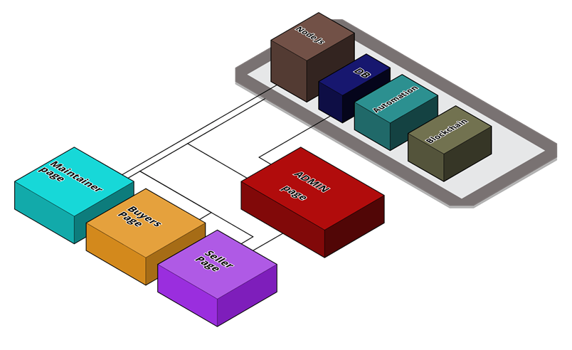

The system architecture of our online marketplace, powered by a backend written in Node.js, is designed for efficiency, security, and seamless user interactions. At its core, the system employs a robust database to store diverse sets of data, including information about products, customers, sellers, administrators, and maintainers. Each entity's data is securely managed and organized within the database, facilitating streamlined operations and ensuring data integrity.

The tech stack employed in the development of the e-commerce platform for local craftsmen is designed to ensure scalability, efficiency, and a seamless user experience. Here's an overview of the technologies and frameworks used:

* Next.js: Next.js is utilized for building the frontend of the platform. Its versatile nature allows for server-side rendering, static site generation, and client-side rendering, ensuring fast performance and SEO optimization. The UI design is crafted using Next.js, leveraging its components and routing capabilities for a dynamic and interactive user interface.
* Node.js: Node.js forms the backbone of the platform, powering the server-side logic and handling asynchronous operations efficiently. Its event-driven architecture and non-blocking I/O make it ideal for building scalable and real-time applications. Node.js is used for implementing various backend functionalities such as user authentication, database operations, and API integrations.
* TRPC Framework: TRPC is employed as the communication layer between the frontend and backend of the platform. It provides a type-safe and efficient way to define and consume APIs, ensuring robust data exchange and error handling. trpc simplifies the process of building APIs and handling requests/responses, enhancing the overall development workflow.
* Tailwind CSS: Tailwind CSS is utilized for styling the user interface of the platform. Its utility-first approach allows for rapid prototyping and customization, enabling developers to create visually appealing designs with minimal effort. Tailwind CSS provides a comprehensive set of pre-built classes for styling components, facilitating consistency and maintainability across the application.
* CMS Payload: Payload serves as the content management system (CMS) for managing the digital content of the e-commerce platform. It offers a user-friendly interface for creating, editing, and publishing content, including product listings, blog posts, and multimedia assets. Payload integrates seamlessly with Next.js and Node.js, enabling dynamic content delivery and personalized experiences for users.
* Resend Mailing System: A robust mailing system is integrated into the platform for managing email communications with users, including order confirmations, promotional campaigns, and customer support notifications. The system is designed to ensure reliable delivery of emails, with features such as email templating, scheduling, and tracking to enhance engagement and retention.
* MongoDB: MongoDB is chosen as the database solution for storing and managing the platform's data. Its document-oriented architecture and flexible schema enable efficient handling of product catalogs, user profiles, and transactional data. MongoDB's scalability and high availability make it well-suited for handling the growing volume of data in an e-commerce environment.

By leveraging this comprehensive tech stack, the e-commerce platform for local craftsmen is equipped to deliver a seamless and immersive shopping experience, empowering artisans to showcase their creations and connect with customers worldwide.

1. **Working Principle:**

   +---------------------+

                      |      User           |

                      +----------+----------+

                                |

                                 v

                     +---------------------+

                     |      Frontend       |

                      +----------+----------+

                                |

                      HTTP Requests/Responses

                                |

                                v

                     +---------------------+

                     |      Backend        |

                      +----------+----------+

                                |

                      API Requests/Responses

                                |

                                 v

                        +-----------------------+

                        |       MongoDB         |

                        +-----------------------+

                                    |

                         Database Queries/Updates

                                    |

                                    v

                        +-----------------------+

                        | External Services    |

                        +-----------------------+

* After the frontend receives HTTP requests from users, it communicates with the backend to handle more complex operations, such as retrieving additional data or performing specific actions.
* The backend processes these requests and may interact with external services, such as payment gateways or shipping providers, to fulfill user requests or update the database with new information.
* The backend also communicates with the MongoDB database to retrieve or update data as needed, ensuring that the platform's information remains accurate and up-to-date.
* Overall, this diagram provides a more detailed view of the interactions between the different components of the e-commerce platform architecture, including additional requests and data flows.
* At the core of our operational approach is an automated product filtration and recommendation system, driven by cutting-edge artificial intelligence. This advanced AI meticulously examines user preferences and past purchase history, enabling the generation of personalized recommendations tailored to each individual. This ensures that users are presented with products that align with their tastes and preferences, enhancing their overall shopping experience.

In tandem with this, our platform employs a secure payment system designed to safeguard the integrity of all transactions. By prioritizing security, we provide a trustworthy environment for both buyers and sellers, instilling confidence in the entire e-commerce process. This dual focus on personalized recommendations through AI and a robust payment system underscores our commitment to delivering a secure, seamless, and user-centric online marketplace through innovative technological solutions.

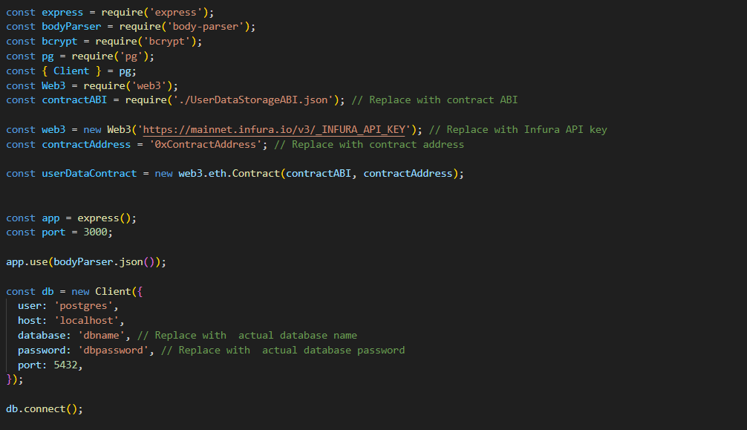

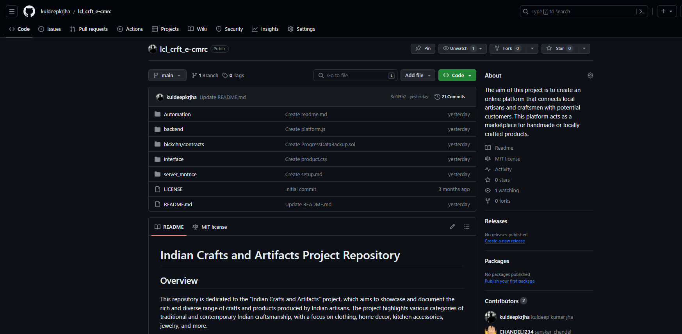

1. **Expected results:**

The envisioned outcomes of our efforts encompass a host of positive changes within the online marketplace. Foremost, users can expect an elevated shopping experience marked by personalized product recommendations, thanks to the integration of artificial intelligence. This tailored approach ensures that users discover products aligned with their preferences, fostering a more engaging and satisfying shopping journey.

Local craftsmen stand to benefit significantly, experiencing heightened visibility and expanded market access. By leveraging our platform, these craftsmen can showcase their unique, handcrafted products to a broader audience, potentially increasing their sales and customer base. This increased exposure provides an invaluable opportunity for local artisans to thrive in the digital marketplace.

The incorporation of blockchain technology is anticipated to yield a significant reduction in fraudulent activities. By securing data through blockchain, the platform becomes more resilient against tampering and unauthorized access, instilling confidence in both buyers and sellers. This heightened level of security contributes to a safer and more trustworthy e-commerce environment.

1. **Individual Contribution:**

|  |  |  |
| --- | --- | --- |
| **Student Name** | **Registration Number** | **Contribution** |
| **Kuldeep Kumar Jha** | **21MEI10060** | **Backend, Tech Stack Finalization** |
| **Yashwardhan Rastogi** | **21MEI10022** | **Payment Gateway, Backend Integration** |
| **Sanskar Singh Chandel** | **21MEI10012** | **Frontend (Product Listing, Admin, Maintainers, Seller, Buyers)** |
| **Manjari Sharma** | **21MEI10050** | **Blockchain Integration, product Listing** |
| **Pankaj Kumar** | **21MEI10021** | **Frontend (Product Listing, Admin, Maintainers, Seller, Buyers)** |
| **Jatin Aggarwal** | **21MEI10056** | **Backend, Payment Gateway** |
| **Rahul Nihalani** | **21MIM10002** | **Product Recommendation Systems (AI)** |
| **Shwetank Thakur** | **21MIM10003** | **Product Recommendation Systems (AI)** |
| **Aman Rathor** | **21BCE11284** | **Frontend (Product Listing, Admin, Maintainers, Seller, Buyers)** |

**5. Conclusion:**

In reaching the conclusion of Phase I, Vikreta attains a pivotal achievement in its developmental journey. The successful implementation of blockchain technology, the incorporation of artificial intelligence for automated recommendations, and the creation of dedicated seller profiles collectively form a resilient foundation for the platform. As we transition into the next phase, our emphasis will pivot towards user testing, assimilating valuable feedback, and refining the platform to ensure a smooth and successful rollout of Phase II. The accomplishments realized in Phase I set the stage for Vikreta to emerge as a transformative and influential platform in championing and preserving the rich tapestry of Indian craftsmanship.

**6. Reference:**

* + [***Ecommerce-website-backend-development***](https://startuptalky.com/ecommerce-website-backend-development/)
  + [***A-complete-guide-on-how-to-develop-an-e-commerce-platform***](https://dev.to/nilmadhabmondal/a-complete-guide-on-how-to-develop-an-e-commerce-platform-17ia)
  + [***Building-scalable-ecommerce-backend-with-microservices-exploring-design-decisions-node-js***](https://medium.com/@nicholasgcc/building-scalable-e-commerce-backend-with-microservices-exploring-design-decisions-node-js-b5228080403b)
  + [***Ecommerce-website-development-project-plan-a-guide-to-your-project-preparation***](https://elogic.co/blog/ecommerce-website-development-project-plan-a-guide-to-your-project-preparation/)